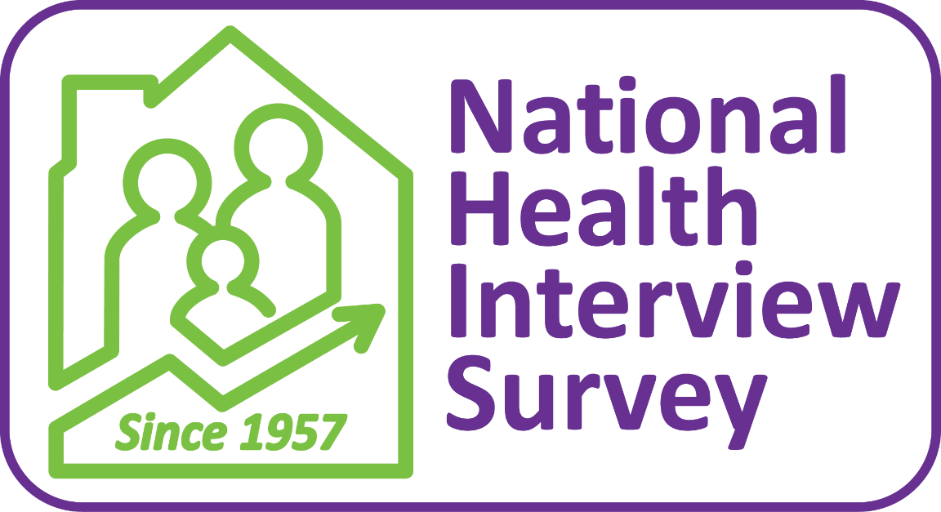

National Health Interview Survey (NHIS) is the principal source of information on the health of the civilian noninstitutionalized population of the United States and is one of the major data collection programs of the NCHS. The National Health Survey Act of 1956 provided for a continuing survey and special studies to secure accurate and current statistical information on the amount, distribution, and effects of illness and disability in the United States and the services rendered for or because of such conditions. The survey referred to in the Act, now called the National Health Interview Survey, was initiated in July 1957. Since 1960, the survey has been conducted by NCHS, which was formed when the National Health Survey and the National Vital Statistics Division were combined.
The main objective of the NHIS is to monitor the health of the United States population through the collection and analysis of data on a broad range of health topics. A major strength of this survey lies in the ability to categorize these health characteristics by many demographic and socioeconomic characteristics.
NHIS data are used widely throughout the Department of Health and Human Services (HHS) to monitor trends in illness and disability and to track progress toward achieving national health objectives. The data are also used by the public health research community for epidemiologic and policy analysis of such timely issues as characterizing those with various health problems, determining barriers to accessing and using appropriate health care, and evaluating Federal health programs.
Since 1957, the content of the survey has been updated about every 10–15 years to incorporate advances in survey methodology and coverage of health topics. In January 2019, NHIS launched a redesigned content and structure that differs from the 1997–2018 NHIS.
Data users can obtain the latest information about the National Health Interview Survey (NHIS) by periodically checking our website: https://www.cdc.gov/nchs/nhis.htm
The website features downloadable data and documentation for the NHIS, as well as important information about any modifications or updates to the data or documentation. Published reports from previous years’ surveys are also available, as are updates about future surveys and datasets. Data files and documentation can be found at: https://www.cdc.gov/nchs/nhis/data-questionnaires-documentation.htm
For information about accessing restricted NHIS variables, see https://www.cdc.gov/rdc/index.htm

